DevOps Assignment 1

Student Details
Name | Ishan Pravin Patil
Roll No / PRN | 123B1B021
Class | BTech Final Year
Division | A
Subject | DevOps

Repository Description
This repository contains all previous FSDL practical assignments and a hosted personal profile website, maintained under a single public GitHub repository as required by the assignment.

Assignments Included
- a1: Assignment 1 - HTML Tags
- a2: Assignment 2 - Personal Profile Website (hosted via GitHub Pages)
- a3: Assignment 3 - React e-commerce UI (Jucci)
- a4: Assignment 4 - Chart.js data visualization
- A5: Assignment 5 - Node.js/Express/EJS travel packages app
- A6: Assignment 6 - Node.js/Express/EJS property listings app
- A7: Assignment 7 - Full stack e-commerce app (React client + Express server)

Technologies Used
HTML, CSS, JavaScript, React.js, Node.js, Express.js, EJS, Chart.js, Git, GitHub, GitHub Actions, GitHub Pages

Hosted Personal Profile Website
Live Link: https://ishan1819.github.io/FSDL/

Repository Link
https://github.com/Ishan1819/FSDL

Final Submission
Name | Ishan Pravin Patil
Roll No | 123B1B021
Class | BTech Final Year
Division | A
GitHub Repository Link | https://github.com/Ishan1819/FSDL
Hosted Website Link | https://ishan1819.github.io/FSDL/
Hosting Platform Used | GitHub Pages (deployed via GitHub Actions workflow)
Technology Stack Used | HTML, CSS, JavaScript, React.js, Node.js, Express.js, EJS, Chart.js

Personal Profile Website - Section Checklist (a2)
- Home section - present (index.html hero)
- About me section - present (about.html)
- Education details - present (about.html)
- Skills section - present (about.html / index.html)
- Projects / assignments section - present (projects.html)
- Contact section - present (contact.html)
- GitHub profile link - present (https://github.com/Ishan1819)
- LinkedIn profile link - present (https://www.linkedin.com/in/ishan-patil18/)

Proof / Screenshots Still Required Before Submission
The following items are documentation proof, not code, and must be captured separately (as images or a PROOF.md) before final submission:
- Screenshot of "git --version" output
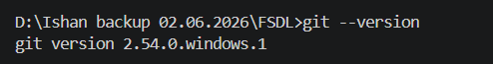

- Screenshot of "git config --global --list" output
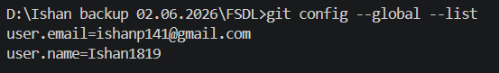

- Screenshot of the local folder structure (a1, a2, a3, a4, A5, A6, A7)
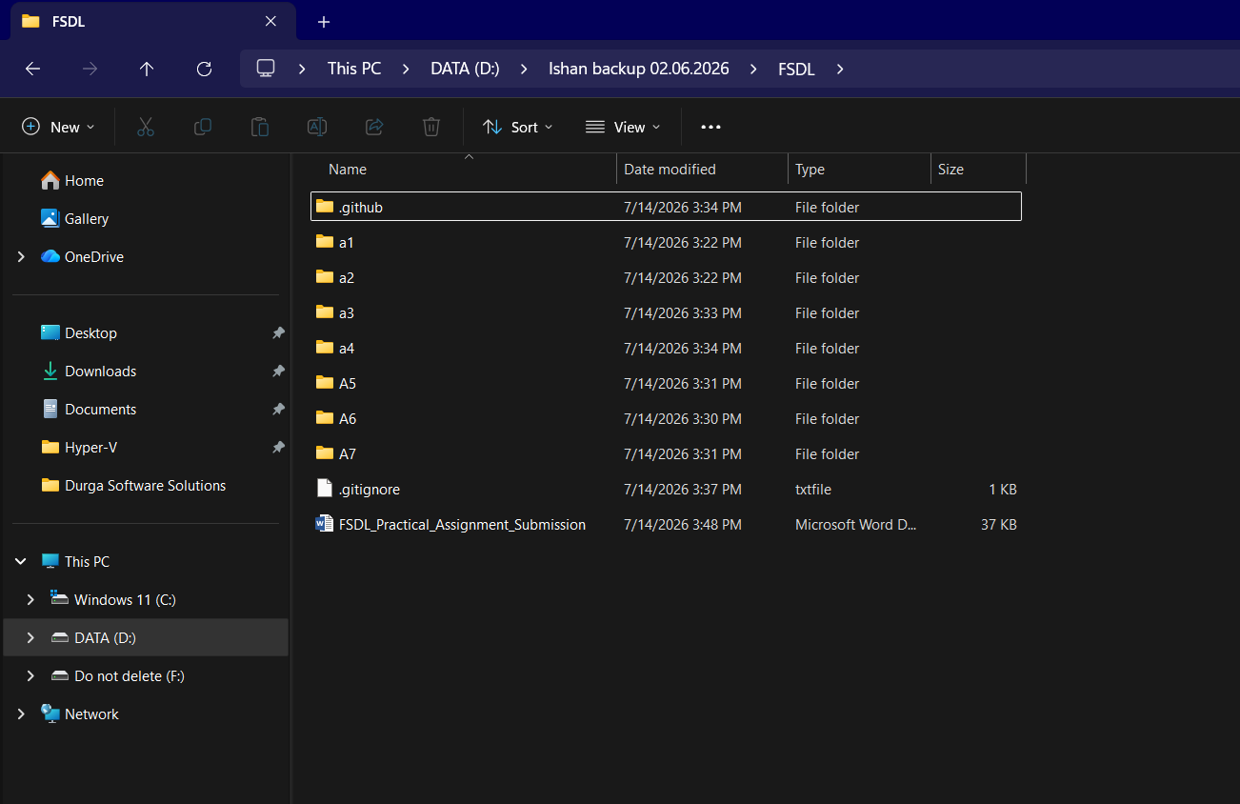

- Screenshot of the public GitHub repository home page
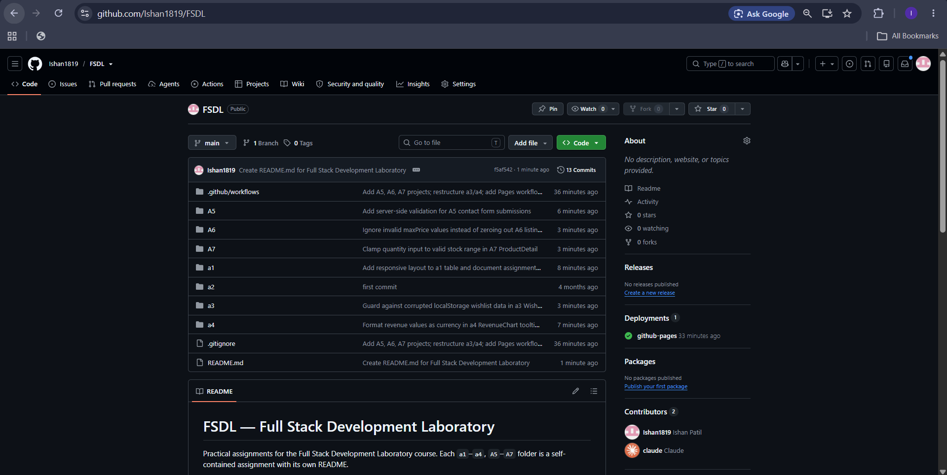

- Screenshot of the commit history (git log --oneline or GitHub commits tab) showing 5+ meaningful commits
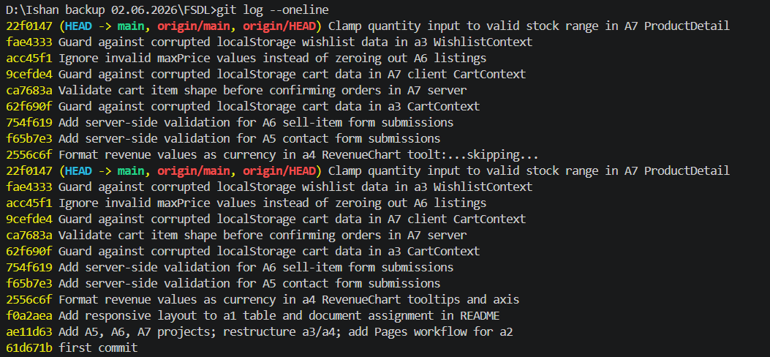

- Screenshot showing all assignment folders inside the repository on GitHub


- Screenshot of GitHub Settings > Pages showing Source = GitHub Actions and the deployed workflow
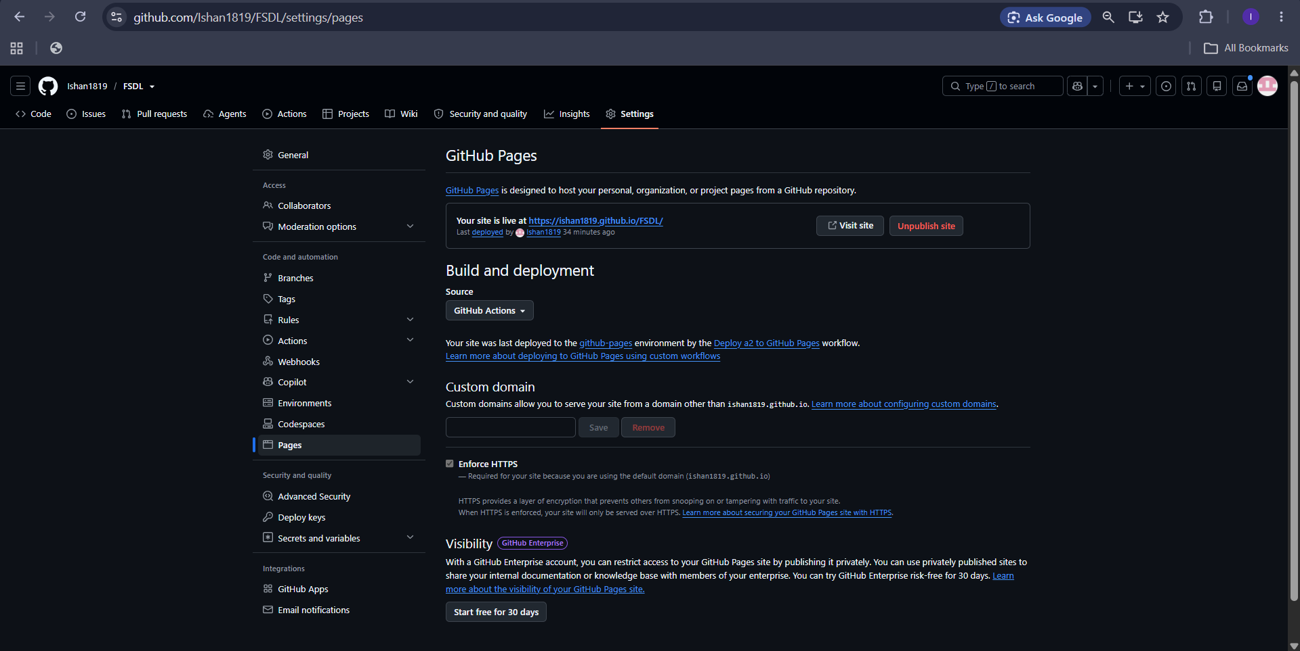

- Screenshot of the live hosted website home page https://ishan1819.github.io/FSDL/
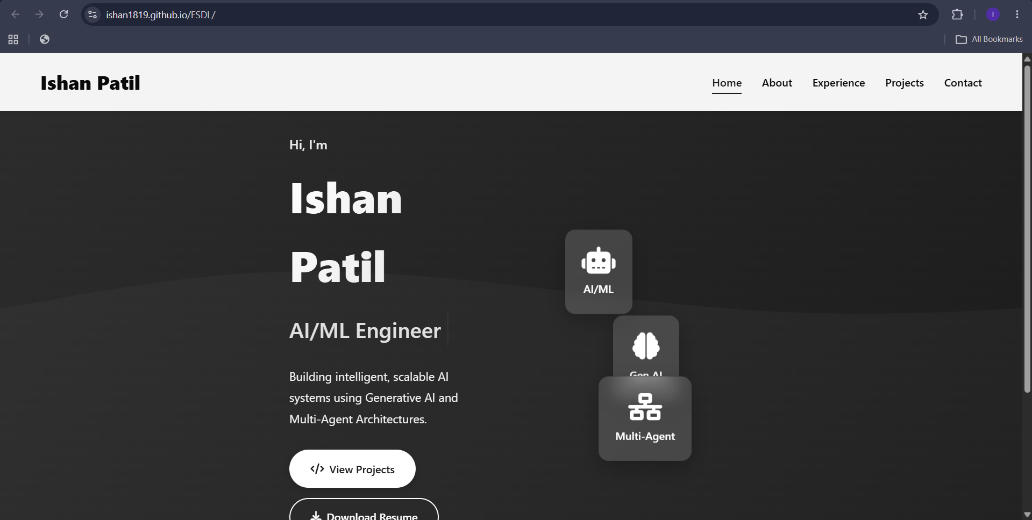

- Screenshot of the GitHub Actions workflow run (green check / successful deployment)
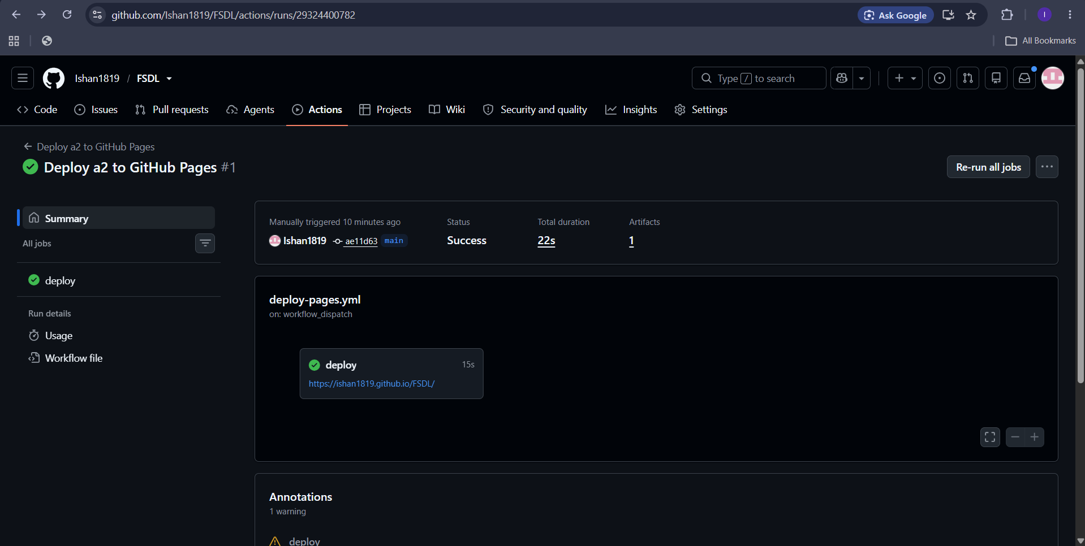

- Screenshot showing a2 files (index.html, css/, js/) inside the repository
